[CEN 323] Computer Organization & Assembly Language
Lab 9 Journal

Name :Bilal Aamir
Enrollment Number:01-135232-016

Lab Deliverables (submission guideline)

Create a folder named after your enrollment number and add the following files:
  - Create a folder named YourRollNumber_Lab1 containing:
- .asm files of the three practice tasks.
- Add full screen screenshots of the code and output in this word file.
  - Zip the Folder and upload it to LMS.

Lab Task

Task 1:
Code (TEXT):
include emu8086.inc

.model small
.data
arr dw 1,2,3,4,5,6,7,8,9,1

.code

mov ax,@data
mov ds,ax

mov cx,10
mov si,0
Print "The Array is : "

MyLoop:

mov bx,arr[si]
push bx
mov dx,bx

mov dh,0
add dl,48
mov ah,02h
int 21h

add si,2

Loop MyLoop

mov cx,10
PrintN ""
Print "Array in Reverse is :"

MyLoop2:

POP DX
mov dh,0
add dl,48
mov ah,02h
int 21h

loop MyLoop2

mov ah,4Ch
int 21h

Screenshot (CODE):
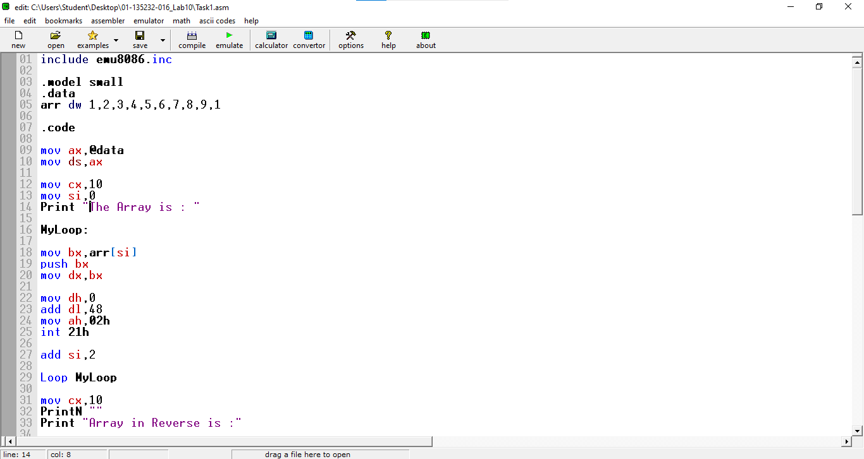

Screenshot (OUTPUT):
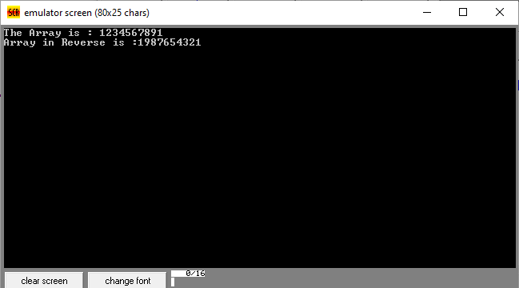

Task 2:
Code (TEXT):
include emu8086.inc

.model small

.data
counter dw 0
divv db 2
num db ?
arr dw ?

.code

mov ax,@data
mov ds,ax

mov cx,10

MyLoop:
Print "Enter the number : "

mov ah,01h
int 21h

PrintN ""

sub al,48
mov num,al

xor ax,ax

mov al,num
div divv

cmp ah,0
JE Even
JMP Cont

Even:
mov bl,num
mov bh,0

Push bx
inc counter

Cont:

Loop MyLoop

Print "The numbers even and less than 5 are :"
PrintN ""
mov cx,counter
CMP cx,0
JE Skip
MyLoop2:

xor bx,bx

POP BX

CMP bx,5
JG Cont2

xor dx,dx
mov dl,bl
add dl,48

mov ah,02h
int 21h

Cont2:

loop MyLoop2
Skip:
mov ah,4Ch
int 21h

Screenshot (CODE):
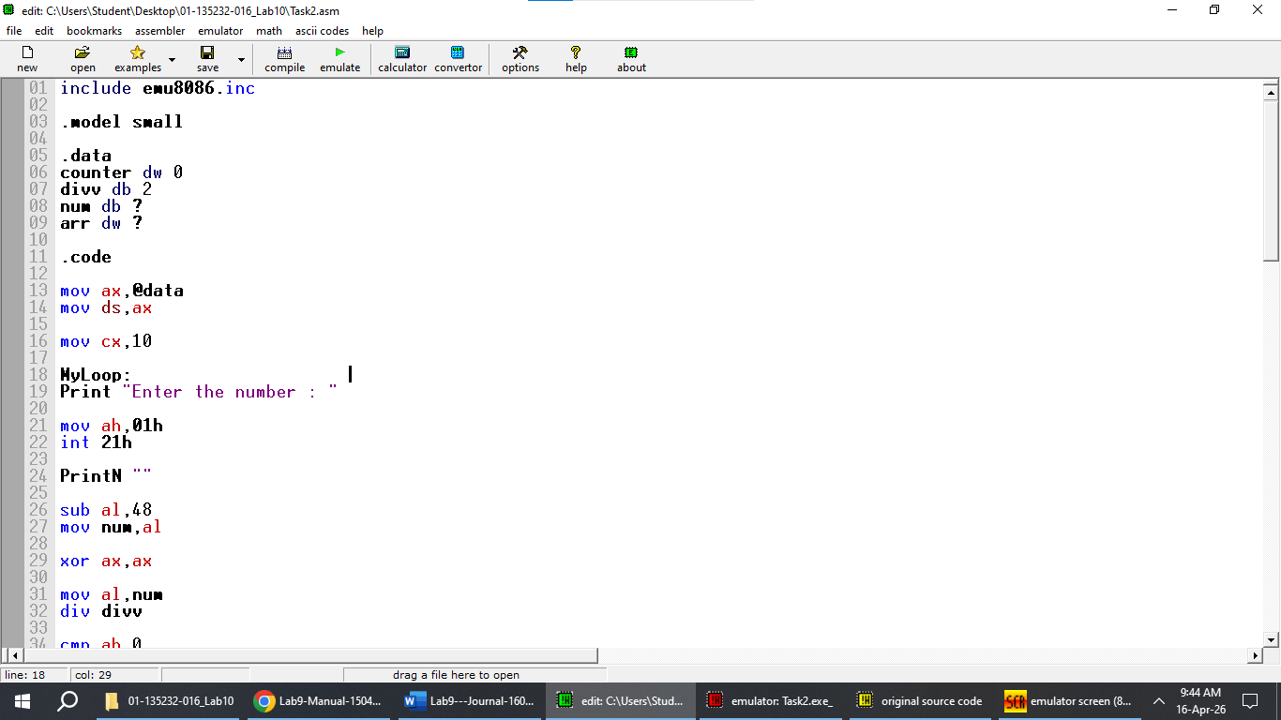

Screenshot (OUTPUT):
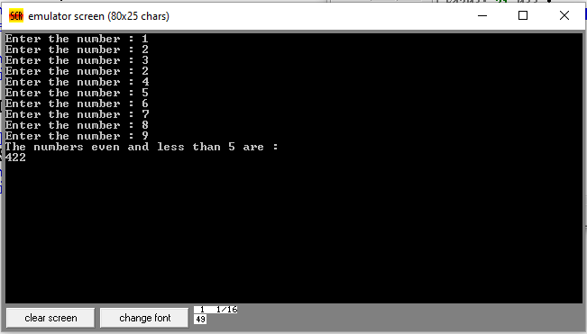

Task 3:
Code (TEXT):
include emu8086.inc

.model small

.data
greatest dw 0
counter dw ?
arr db ?
.code

mov ax,@data
mov ds,ax

Loopp:

Print "Enter the number : "

mov ah,01h
int 21h

PrintN ""

CMP al,13
JE Exit

mov ah,0
sub al,48
PUSH AX
inc counter

jmp Loopp
Exit:
PrintN ""
Print "You Pressed Enter key "
PrintN ""
mov cx,counter

MyLoop:

POP BX
CMP greatest,bx
JL greater
jmp skipp
greater:
XCHG greatest,bx
skipp:

loop MyLoop

xor dx,dx
mov dx,greatest
add dl,48

Print "The greatest number is :"
mov ah,02h
int 21h

mov ah,4Ch
int 21h

Screenshot (CODE):
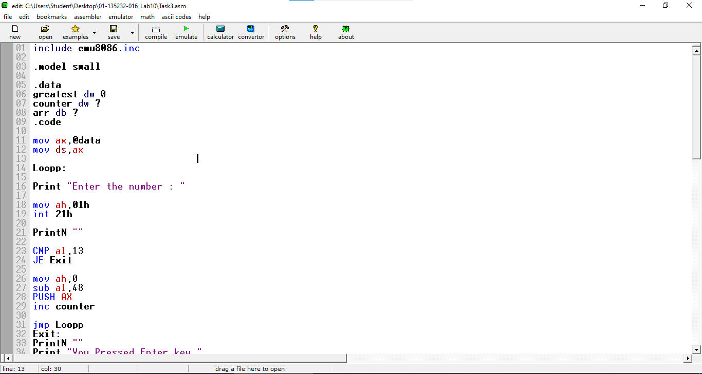

Screenshot (OUTPUT):

